Ideation Phase

Empathize & Discover
Date | 1 November 2025
Team ID | NM2025TMID05413
Project Name | Educational Organisation Using ServiceNow
Maximum Marks | 4 Marks

Empathy Map Canvas:
In the Empathize & Discover phase, the team observed how students, faculty, and administrators interact within an educational institution’s daily operations. It was discovered that many processes—such as student admission, timetable management, and feedback handling—are still done manually or across disconnected systems.
Through interviews and surveys, users expressed frustration over delays in approvals, lack of transparency, and communication gaps. Teachers find it difficult to track student performance efficiently, while students struggle to get timely updates or raise queries easily.
These insights highlight the need for a unified digital platform to automate workflows, centralize data, and enhance user interaction. By understanding these challenges deeply, the team was able to design a ServiceNow-based system that simplifies educational administration, ensures smooth communication, and supports data-driven decision-making.
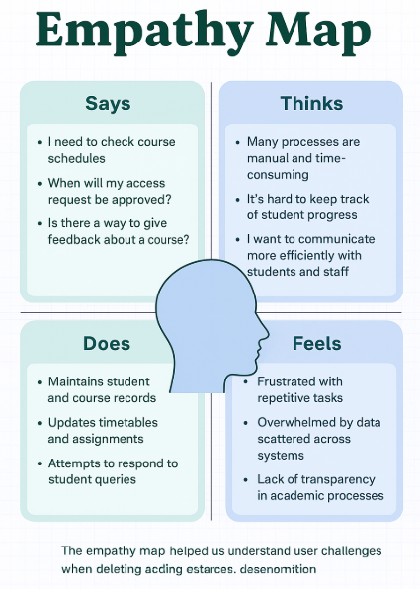
Reference: https://www.mural.co/templates/empathy-map-canvas

The empathy map helped us understand:
The daily struggles of users in managing academic and administrative activities. It revealed pain points such as:
- Repetitive manual processes
- Communication gaps between departments
- Lack of access to real-time academic information
- Difficulty tracking tasks and feedback
By empathizing with students, faculty, and administrators, the team designed an Educational Management System using ServiceNow that integrates workflow automation, digital forms, and centralized dashboards. This helps institutions reduce workload, minimize errors, and enhance collaboration across all levels.

Example: Educational Management System
By deeply understanding the user perspectives through empathy mapping, we identified critical frustrations and workflow inefficiencies across educational departments. These included scattered data storage, slow approvals, and inconsistent communication.
The resulting ServiceNow-based system includes:
- Automated student registration and staff management
- Digital feedback and query system
- Centralized dashboards for academic tracking
- Automated notifications and approval workflows
This ensures smoother operations, improved accountability, and a more connected educational experience for everyone.
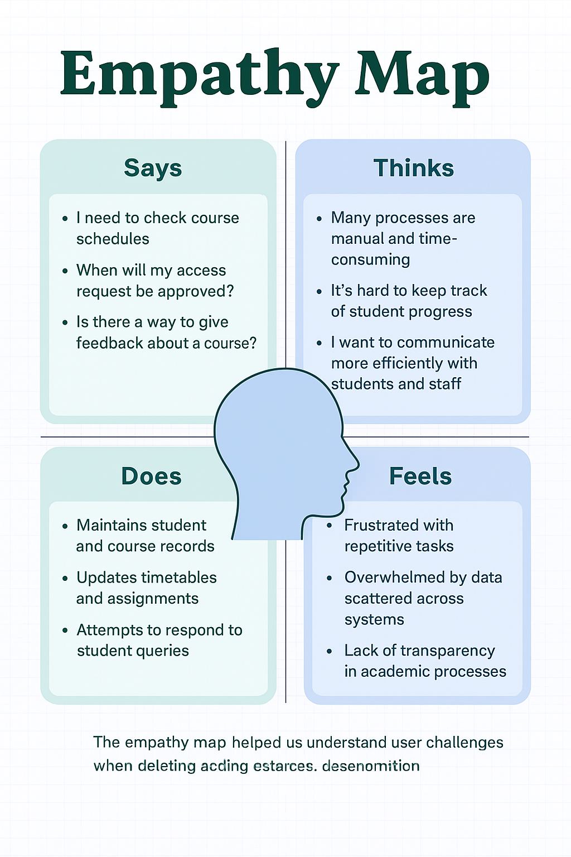
Fig: Empathy Map for Educational Organization using ServiceNow

